Cse370 Lab Assgnment 04

Deadline: 31-07-2023 11:59 pm

Name: Ms Rodsy Tahmid

Id: 20101021

Sec-06

mysql -u root -p

show databases;

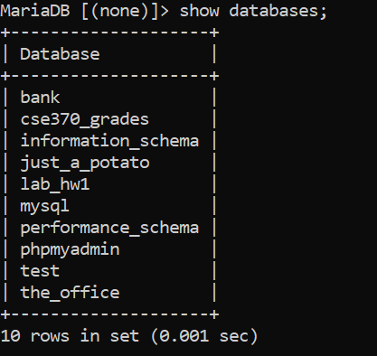

use Bank;

show tables;

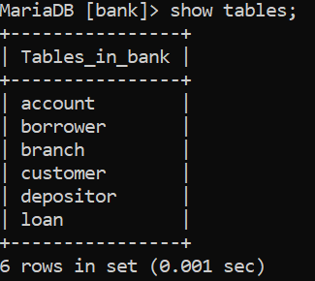

Select * from customer;

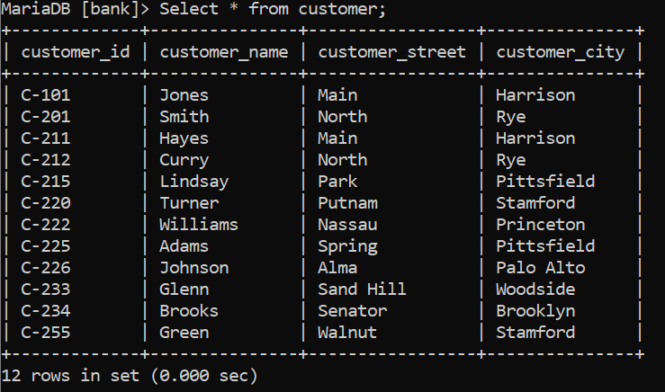

Select * from branch;

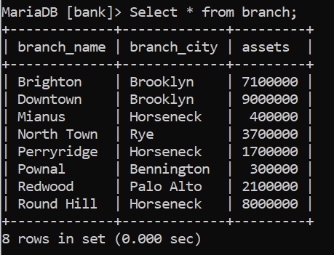

Select * from account;

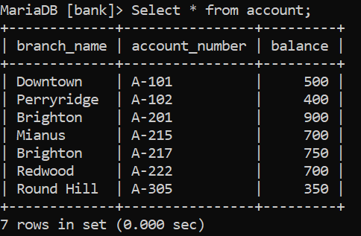

Select * from loan;

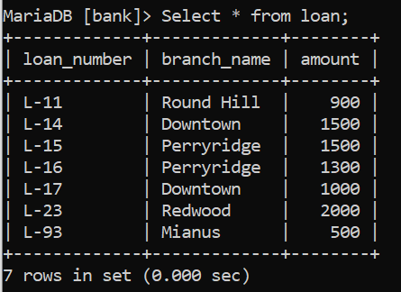

Select * from depositor;

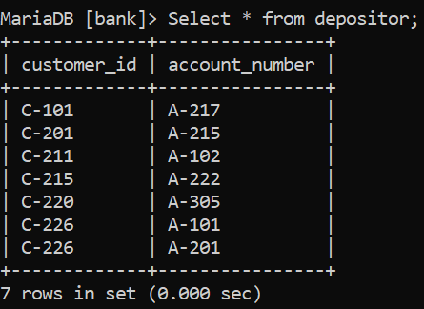

Select * from borrower;

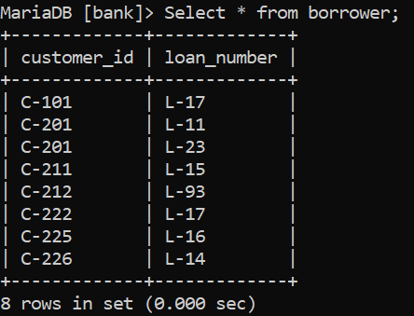

1.

Select customer_name, loan.loan_number from ((customer inner join borrower on customer.customer_id = borrower.customer_id) inner join loan on loan.loan_number = borrower.loan_number) where branch_name = 'Downtown';

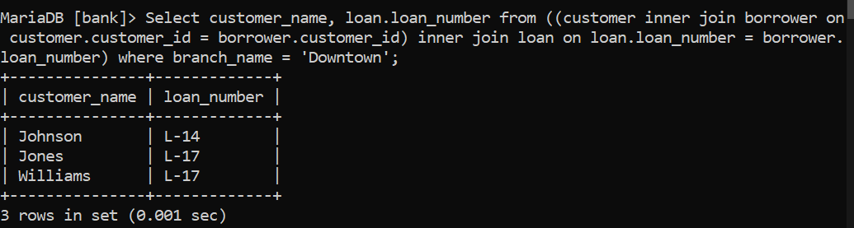

2.

Select customer1.customer_name as Customer1, customer2.customer_name as Customer2, customer1.customer_city from customer customer1 join customer customer2 on customer1.customer_city=customer2.customer_city and customer1.customer_name< customer2.customer_name;

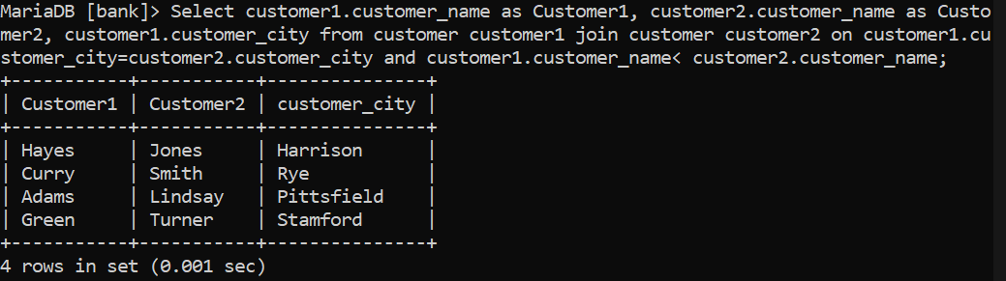

3.

Select branch_name , sum(balance*4/100) as total_interest from account group by branch_name;

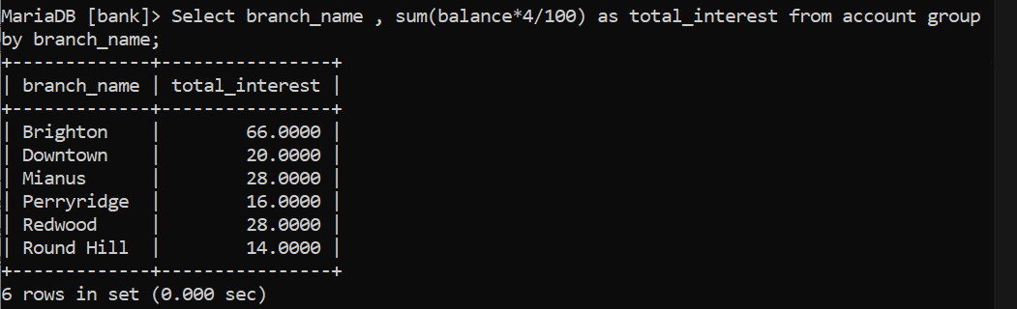

4.

Select depositor.account_number, max(account.balance) as highest_balance, customer.customer_city from (customer inner join depositor on customer.customer_id = depositor.customer_id) inner join account on depositor.account_number = account.account_number group by customer.customer_city;

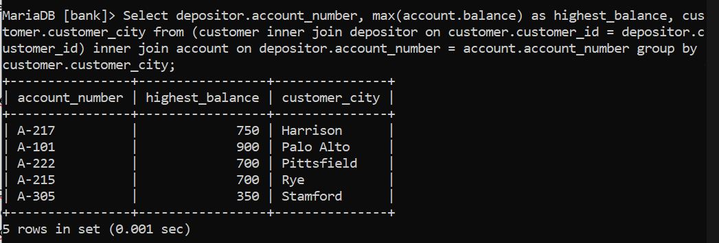

5.

Select * from (select loan.loan_number, amount, customer_name from loan inner join borrower on loan.loan_number = borrower.loan_number inner join customer on customer.customer_id = borrower.customer_id order by amount desc limit 5) as table1 order by amount, loan_number desc;

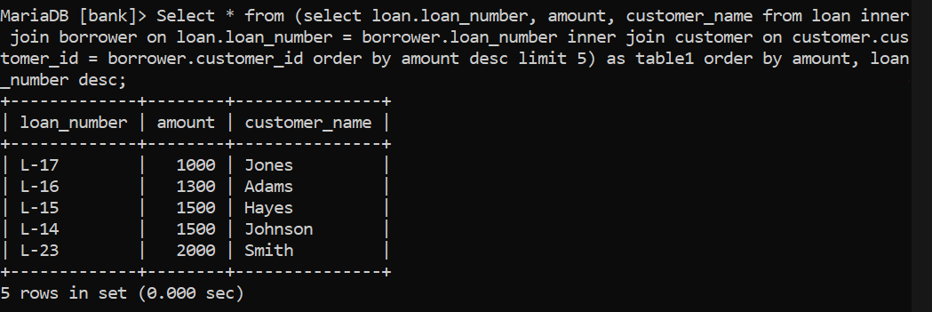

6.

Select customer.customer_name from ((loan inner join account on loan.branch_name = account.branch_name) inner join borrower on loan.loan_number = borrower.loan_number) inner join customer on borrower.customer_id = customer.customer_id where account.branch_name = "Perryridge" and loan.branch_name = "Perryridge" group by account.branch_name;

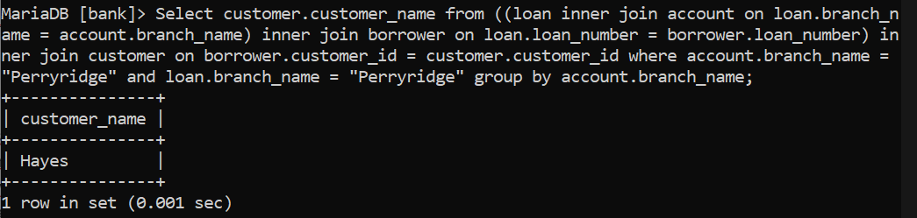

7.

Select customer.customer_name, sum(loan.amount) as Total_Loan from (loan inner join borrower on loan.loan_number = borrower.loan_number) inner join customer on borrower.customer_id = customer.customer_id group by customer.customer_id having count(*)>=2;

